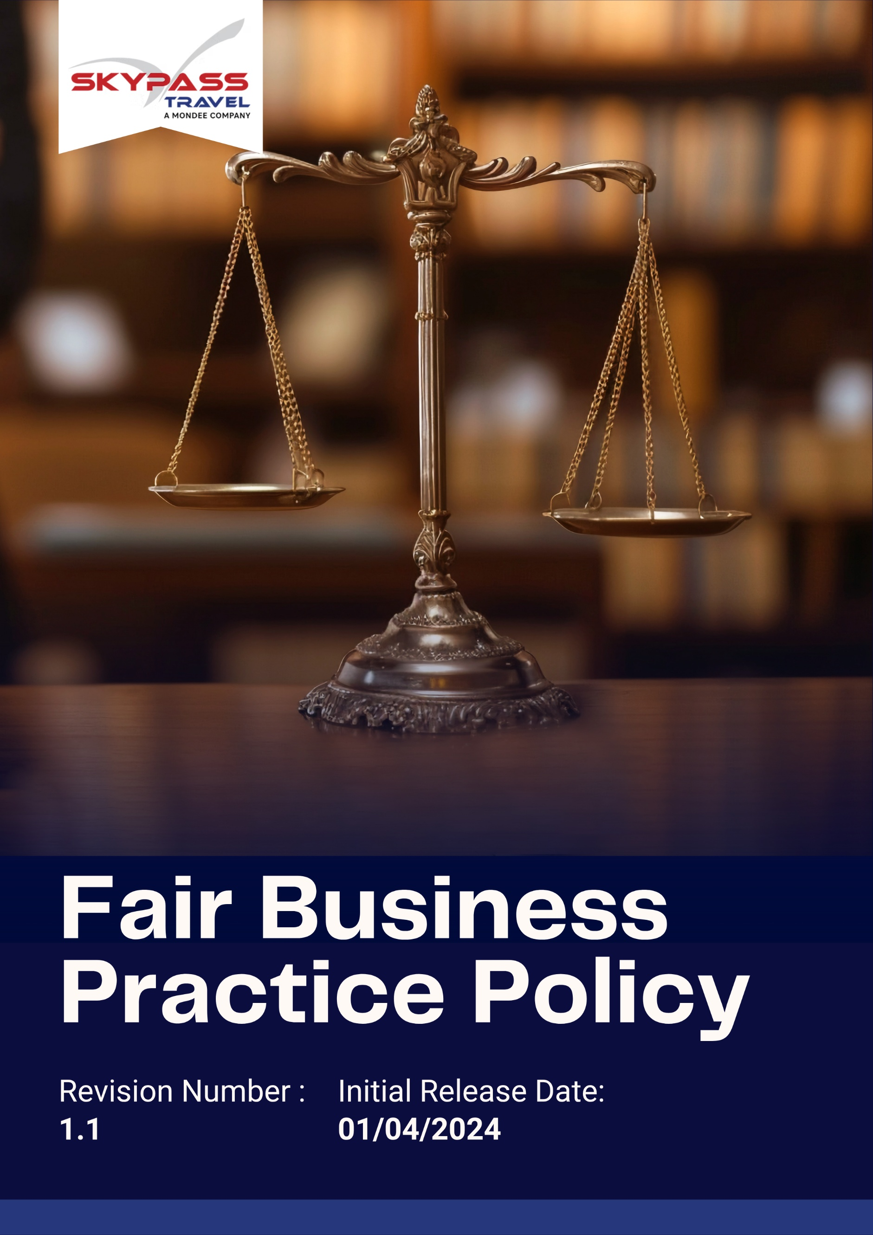

Overview
We recognize that ethical conduct is the foundation of trust, credibility, and long-term business success. We aim to operate responsibly in all markets and with all stakeholders, including employees, customers, suppliers, and partners. We are willing to continually strengthen our governance, compliance, and accountability measures to uphold the highest standards of integrity. We will integrate ethical practices into decision-making, daily operations, and relationships, ensuring that every action reflects our commitment to honesty, transparency, and respect.

Purpose
We aim to establish a clear framework that guides all Skypass Travel employees, partners, and stakeholders in acting ethically and responsibly. We will:
- Promote a culture of honesty, accountability, and compliance with applicable laws and regulations.
- Prevent unethical practices, including corruption, bribery, fraud, conflicts of interest, anti-competitive behavior, and misuse of confidential information.
- Ensure that our decisions and actions reflect fairness, transparency, and responsibility toward stakeholders.
- Continuously improve our ethical standards through training, monitoring, and feedback mechanisms.

Applicability
This Fair Business Practice Policy applies to all operations, business functions, and services of Skypass Travel Inc. (Group) across all locations worldwide, including corporate offices, registered offices, branch offices, subsidiaries, joint ventures, and all associated supply chain activities. It is applicable to all employees, workers, contractors, and stakeholders engaged with Skypass Travel Inc. (Group), directly or indirectly, and requires strict compliance and accountability at every organizational level.

Policy Statement
Our organization is committed to conducting all business activities with integrity, transparency, and fairness. We uphold the highest ethical standards, promote accountability, and expect all employees and stakeholders to act honestly, responsibly, and in compliance with applicable laws and regulations.

Our Priorities
- Promote a culture of honesty, respect, and fairness in all business dealings.
- Prevent corruption, bribery, and any form of unethical behaviour.
- Ensure transparent decision-making and accountability across all levels.
- Protect confidential information and respect privacy rights.
- Encourage reporting of unethical conduct without fear of retaliation.

Ethical Objectives and Targets

A. Anti-Corruption and Bribery
- We aim to foster a zero-tolerance culture toward bribery, fraud, and corruption by embedding ethical practices across all operations.
- We will establish a robust internal anti-corruption management system integrated into all business processes.
- We will conduct regular ethics and integrity workshops to reinforce a culture of honesty and compliance.
- We will ensure all charitable donations, sponsorships, and gifts are lawful, transparent, and pre-approved.
- We aim for 75% of employees and 15% of suppliers to be trained annually on anti-bribery and corruption awareness by 2030 from baseline year 2022.
- We aim for zero incidents of confirmed bribery, fraud, or facilitation payments by 2030.
- We will ensure 40% of third-party agents and vendors are evaluated for ethical compliance before engagement by 2030 from baseline year 2022.

B. Fraud Prevention and Financial Integrity
- We aim to foster a zero-tolerance culture toward bribery, fraud, and corruption by embedding ethical practices across all operations.
- We will maintain a culture of financial honesty through continuous communication and oversight.
- We will strengthen internal financial controls and implement automated monitoring tools.
- We are willing to promote whistleblower protection and anonymous reporting.
- We aim for 50% of employees to be trained annually on fraud prevention by 2030 from baseline year 2022.
- We will ensure 75% of departments undergo annual internal audit and risk assessment by 2030 from baseline year 2022.
- We will ensure 10% of third-party agents and vendors are evaluated for fraud compliance before engagement by 2030 from baseline year 2022.
- We aim for zero unresolved cases of financial irregularities by 2030.

C. Conflict of Interest
- The Company prohibits personnel with family relation to work in the same department.
- We will foster a workplace culture where disclosure and transparency are standard practice.
- We aim to integrate conflict-of-interest evaluation into performance review and supplier selection.
- We will promote employee awareness on impartiality and professional responsibility.
- We will ensure 100% of employees complete annual Conflict of Interest Declaration forms by 2030 from baseline year 2022.
- We aim for 100% of reported conflicts to be reviewed and resolved within 30 calendar days by 2030 from baseline year 2022.
- We will ensure 40% of employees and leadership staff are trained on ethical decision-making principles by 2030 from baseline year 2022.

D. Fair Competition and Antitrust Compliance
- We will develop a global compliance framework for competition and antitrust laws.
- We aim to reinforce ethical negotiation, tendering, and partnership practices across all departments.
- We will foster an internal culture of fairness and merit-based business decisions.
- We will ensure 100% of senior managers and sales teams are trained on fair competition and antitrust compliance by 2030 from baseline year 2022.
- We aim for zero confirmed incidents of anti-competitive practices or price manipulation by 2030.
- We will ensure 100% of joint ventures, mergers, and partnerships are screened for legal and ethical compliance by 2030 from baseline year 2022.

E. Information Security and Confidentiality
- We will strengthen cybersecurity infrastructure and conduct annual penetration tests.
- We will implement and maintain robust cybersecurity controls, including access management, encryption, firewalls, multi-factor authentication, endpoint protection, and data loss prevention, aligned with international standards (e.g., ISO 27001, GDPR).
- We will build an organizational culture emphasizing confidentiality, trust, and responsible data use.
- We will ensure 100% of employees are trained annually on information security awareness by 2030 from baseline year 2022.
- We aim for zero confirmed data breaches or unauthorized disclosures by 2030.
- We will achieve ISO 27001 Information Security Management certification by 2028.
- We will respond to all IT security incidents within 12 hours of detection by 2030.

F. Anti-Money Laundering (AML) Compliance
- We aim to foster a zero-tolerance culture toward money laundering, terrorist financing, and financial crime by embedding strong AML practices across all operations.
- We will establish and maintain a robust AML compliance program aligned with national and international regulations.
- We will ensure 100% of customers, vendors, and third parties undergo KYC and due diligence checks before engagement by 2030 from baseline year 2022.
- We will conduct regular AML awareness and training sessions to ensure 100% of employees understand red-flag indicators and reporting obligations by 2030.
- We will implement automated monitoring and reporting systems to identify and report suspicious transactions promptly.
- We aim for zero confirmed incidents of money laundering or non-compliance with AML laws by 2030.
- We will ensure 100% of AML-related risks are reviewed and mitigated through annual internal audits and continuous monitoring by 2030.
- We will embed ethical conduct and anti-money laundering clauses into all supplier contracts.
- We will strengthen partnerships with vendors who demonstrate social and environmental responsibility.

G. Whistleblowing, Reporting, and Accountability
- We will establish a globally accessible Ethics Helpline for reporting unethical practices.
- We aim to promote a culture of speaking up without fear of retaliation.
- We aim for 100% of reported ethical concerns to be acknowledged within 48 hours by 2030 from baseline year 2022.
- We will ensure 100% of investigations are completed within 15 working days by 2030 from baseline year 2022.
- We aim for zero incidents of retaliation against whistleblowers by 2030.

Disciplinary Measures for Violations
We are committed to maintaining the highest standards of ethical conduct throughout all operations of Skypass Travel Inc. (Group). Any breach of this Fair Business Practice Policy, whether intentional or unintentional, will be taken seriously and addressed promptly through fair and transparent disciplinary processes.
Verbal or Written Warning: In cases of minor or first-time ethical lapses, employees or stakeholders may receive a formal warning and be required to attend counseling sessions or additional ethics training to reinforce compliance expectations.
Corrective Action or Performance Review: Where misconduct has occurred due to negligence or poor judgment, the individual may be placed under a structured corrective action plan. This may include close supervision, reassessment of responsibilities, or mandatory participation in an ethics improvement program.
Suspension or Demotion: For repeated violations or serious ethical breaches, employees may face temporary suspension without pay or reassignment to a lower position. This measure serves both as a corrective step and as a signal of the organization’s intolerance toward unethical practices.
Termination of Employment or Contract: In severe cases such as fraud, bribery, corruption, or misuse of confidential information, immediate termination of employment or business relationship will be enforced. Skypass Travel reserves the right to recover financial losses and pursue restitution where applicable.
Supplier or Partner Disqualification: Vendors, contractors, or business partners who violate Skypass Travel’s ethical standards may face termination of agreements, blacklisting, or permanent disqualification from future collaborations. Continuous non-compliance will be escalated to higher authorities within the company or externally if required.
Legal Action and Reporting to Authorities: Violations involving corruption, fraud, bribery, money laundering, or other criminal offenses may lead to legal proceedings, including criminal prosecution, financial penalties, and cooperation with relevant enforcement agencies as per applicable local and international laws.

Guidelines for Employees
1. Integrity in Decision-Making
- We will make all business decisions based on honesty, transparency, and fairness. Employees must avoid situations where personal interests could influence professional judgment.
- We aim to foster a culture where ethical decision-making is a daily practice and conflicts of interest are disclosed promptly.
Example:
✅ An employee discloses that a family member owns a travel agency before approving a vendor contract.
❌ Favouring a friend’s business for personal gain without disclosure or approval.
2. Anti-Corruption and Bribery
- We will not offer, solicit, or accept any bribes, facilitation payments, or inducements. All gifts, entertainment, or sponsorships must comply with legal and company standards.
- We aim to ensure transparency in all transactions and require pre-approval for any benefits provided to clients or partners.
Example:
✅ Sending a small, company-approved token of appreciation to a client.
❌ Giving cash or expensive gifts to influence contract awards.
3. Confidentiality and Data Protection
- We will handle all company, customer, and employee data responsibly, safeguarding information from unauthorized access, sharing, or misuse.
- We aim to comply with all applicable local and international privacy regulations and maintain trust with our clients and partners.
Example:
✅ Sharing client itineraries only with authorized team members for operational purposes.
❌ Posting internal pricing or sensitive client information on social media.
4. Reporting Ethical Concerns
- We will promptly report any suspected violations of this policy, legal breaches, or unethical practices through designated whistleblowing channels.
- We aim to create an environment where employees can report concerns without fear of retaliation.
Example:
✅ Reporting manipulated travel invoices to the Ethics Helpline.
❌ Ignoring observed fraudulent or unethical behavior.
5. Fair Competition
- We will compete responsibly, adhering to antitrust laws and fair business practices in all markets.
- We aim to prevent collusion, market manipulation, or sharing confidential competitor information.
Example:
✅ Submitting independent competitive bids in compliance with competition laws.
❌ Coordinating pricing or market allocation strategies with competitors.
6. Responsible Use of Company Resources
- We will use company assets, funds, and information strictly for legitimate business purposes and avoid personal benefit or misuse.
- We aim to maintain accountability for all resources, ensuring they are used efficiently and ethically.
Example:
✅ Using a corporate travel card solely for business trips.
❌ Using company funds or equipment for personal travel or side businesses.
7. Professional Conduct and Workplace Behavior
- We will treat all colleagues, clients, and stakeholders with respect, professionalism, and fairness. Harassment, discrimination, or bullying is strictly prohibited.
- We aim to create a safe, inclusive, and collaborative workplace where every individual can perform to their full potential.
Example:
✅ Providing constructive feedback to a colleague in a professional manner.
❌ Making derogatory remarks, threats, or discriminatory comments toward coworkers.
8. Compliance with Laws and Regulations
- We will follow all applicable local, national, and international laws affecting our business operations.
- We aim to stay informed about legal changes and ensure that our actions consistently reflect compliance.
Example:
✅ Processing all visa applications in accordance with immigration laws.
❌ Forging documents to bypass visa requirements or circumvent legal obligations.
9. Ethical Communication and Marketing
- We will communicate honestly and accurately in all corporate communications, advertising, and marketing materials.
- We aim to avoid misleading statements or false representations that could harm the company’s reputation or stakeholders.
Example:
✅ Publishing accurate travel package information to clients.
❌ Exaggerating services or misrepresenting pricing to win business.

Governance of this Policy
We will ensure that this Fair Business Practice Policy Policy is governed by a structured framework to promote accountability, transparency, and adherence across all levels of Skypass Travel Inc. (Group). The Ethics Committee will oversee the implementation, monitoring, and enforcement of the policy, ensuring alignment with legal requirements and best practices. We aim to foster a culture where ethical conduct is embedded in every operational and strategic decision.

Responsibility for this Policy
1. Board of Directors
- Provide overall leadership, endorse the Fair Business Practice Policy, and allocate necessary resources to support its implementation.
- Ensure that ethical considerations are integrated into all strategic decisions, corporate governance practices, and business operations.
- Review reports of significant ethical risks and violations and take timely corrective action.
2. Chief Compliance Officer
- Review the entire policy annually or as per needed
- Oversee day-to-day implementation of the Fair Business Practice Policy, monitor compliance, and provide guidance on ethical dilemmas.
- Conduct regular audits, risk assessments, and investigations of reported misconduct.
- Ensure employees and partners are trained, informed, and supported in understanding and adhering to ethical standards.
3. Managers and Supervisors
- Fostering a culture of integrity, fairness, and transparency within their teams.
- Ensure that team members understand their responsibilities under this policy and have access to reporting channels.
- Address potential ethical risks proactively and escalate concerns to the Ethics Committee when necessary.
4. Employees and Stakeholders
- Follow the guidelines of employees mentioned in this policy
- Comply with all provisions of this Fair Business Practice Policy in our daily actions and decision-making.
- Report any suspected violations, conflicts of interest, or unethical behavior promptly through designated channels.
- Participate in ongoing training, awareness programs, and continuous improvement initiatives related to ethical conduct.
5. Suppliers, Contractors, and Business Partners
- Uphold ethical standards equivalent to those of Skypass Travel when engaging in business activities or representing the company.
- Ensure that all contractual agreements include ethics and compliance clauses, and we will be accountable for monitoring adherence.

Reporting
We will establish secure, accessible, and confidential reporting channels to encourage employees, partners, and stakeholders to report suspected ethical violations, misconduct, or non-compliance. We aim to ensure that:
- All concerns are treated seriously, investigated promptly, and documented accurately.
- No retaliation or adverse action will be taken against individuals who report in good faith.

Continuous Improvement
We will continuously monitor, evaluate, and improve our ethical practices and systems. We aim to:
- Conduct periodic training and awareness programs to reinforce ethical behavior.
- Implement lessons learned from investigations to strengthen controls.
- Benchmark against international standards and incorporate best practices to enhance governance.
- Encourage feedback from employees, customers, and partners to identify gaps and opportunities for improvement.

Review Mechanism for this Policy
Chief Compliance Officer will review this Fair Business Practice Policy at least once every year or earlier if significant operational, regulatory changes occur. The Chief Compliance Officer is the responsible for conducting the review, assessing policy effectiveness, and recommending updates or improvements as necessary.
Next Review Date: 01-04-2026

Approved By – Managing Director
Skypass Travel Inc. (Group)

Acknowledgement
I hereby acknowledge that I have received, read, and understood the Skypass Travel’s Fair Business Practice Policy. I understand the company’s commitment to ethical conduct, integrity, and compliance, including its focus areas, qualitative and quantitative targets, and my responsibilities as an employee, contractor, or stakeholder to support and comply with this policy.
I agree to:
- Adhere to all guidelines, procedures, and ethical standards outlined in the policy.
- Act responsibly, honestly, and transparently in all business interactions and decisions.
- Participate in training, awareness programs, and compliance initiatives as required.
- Report any suspected ethical violations, misconduct, or conflicts of interest promptly through designated reporting channels.
I understand that compliance with this policy is a fundamental part of my responsibilities and that failure to comply may result in disciplinary action, up to and including termination or legal consequences.
Employee Name :
Signature:
Date:

